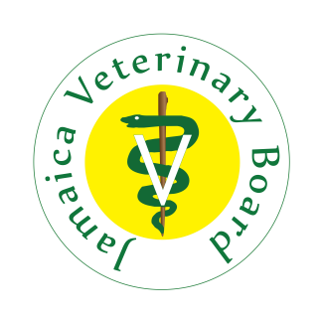

JAMAICA VETERINARY BOARD
Email: jvb@moa.gov.jm

APPLICATION FOR LETTER OF GOOD STANDING

NAME OF APPLICANT: ___________________________________________________________________
APPLICANT’S REGISTRATION NUMBER: ____________________________________________________
PARTICULARS OF ORGANIZATION/ PERSON TO WHOM LETTER SHOULD BE DIRECTED:
Contact person: _________________________________________________________________
Address : _________________________________________________________________
_________________________________________________________________
_________________________________________________________________
Email address: _________________________________________________________________
An application fee of $2,500.00 is to be paid to the Jamaica Veterinary Board for each letter required.
Method of submission of letter: Regular Mail □ Email□ Collection by applicant□
SIGNATURE OF APPLICANT: _____________________________
DATE OF APPLICATION: ________________________________
For Internal Use Only
Date Application Received: ______________________________________________________________
Payment receipt Number: ______________________________________________________________
Letter approved: Yes ____ No____
Date of letter delivery (if applicable): ______________________________________________________
Registrar’s Signature: ___________________________________________________________________

